1. **RESUME**

# **MANOHAR T H**

**Phn-No:** 7795278491

**Email-ID:** manohar017manu@gmail.com

# **CAREER OBJECTIVE**

To work in an organization which provides me with ample opportunities to enhance my skills and knowledge along with contributing to the growth of the organization.

# **ACADEMIC QUALIFICATION**

|  |  |  |  |
| --- | --- | --- | --- |
| **QUALIFICATION** | **INSTITUTION** | **YEAR OF PASSING** | **PERCENTAGE** |
| **BCA** | SeshadripuramDegree college. (Tumkur University) | Pursuing | 1st sem-.74.45% |
| 2nd sem-87.38% |
| 3rdsem- 79.23% |
|  |  |  | 4thsem-82.3% |
| **PUC** | Seshadripurm Pre-University  College, Tumkur. (Karnataka Board) | 2020 | 73.4% |
| **SSLC** | Bishop Sargant School  (ICSE Board) | 2018 | 74.4% |

**TECHNICAL SKILLS**

* Programming Languages : C ,Python ,Java, and C++.
* Web Technologies: HTML and CSS.
* Database: MySQL ,PHP.
* Others : VS code,Github,Firebase.

**SKILL SET**

* Self motivator,
* Grasping power,
* Problem solving,
* Positive attitude
* Teamwork and collaboration

# **ACADEMIC PROJECT**

* **Zbudget:** ZBudget is a web based static Project that help the peoples to find the daily wage workers and their dream House at a single platform
* **MediMate :** Medimate is dynamic based web application that helps in various Clinics based Management system

# **ACHIEVEMENTS**

* Volunteer in college events and coding club.
* Participated in Google developers Meet 2022.
* Participated in various Coding computations

# **PERSONAL INFORMATION**

|  |  |  |  |
| --- | --- | --- | --- |
| **DATE OF BIRTH** |  |  | :17-03-2003 |
| **GENDER** |  |  | : Male |
| **LANGUAGES KNOWN** |  |  | :Kannada, English. |
| **AREA OF INTEREST** |  |  | : Cyber Security and Full stack developer |
| **FATHER NAME** |  |  | : T M Hanumantha Raju |
| **MOTHER NAME** |  |  | : Hemavathi K R |
| **ADDRESS** |  |  | : #86 Jodi Thimasandra,  madure(H),Dodabalapur(T),  Bangalore Rural-561204 |

I hereby confirm that the information provided above is true and correct to the best of my Knowledge.

**Date :** 17-07-23

**Place:** Tumkur

1. **MARKS CARD**

**First Semester:**

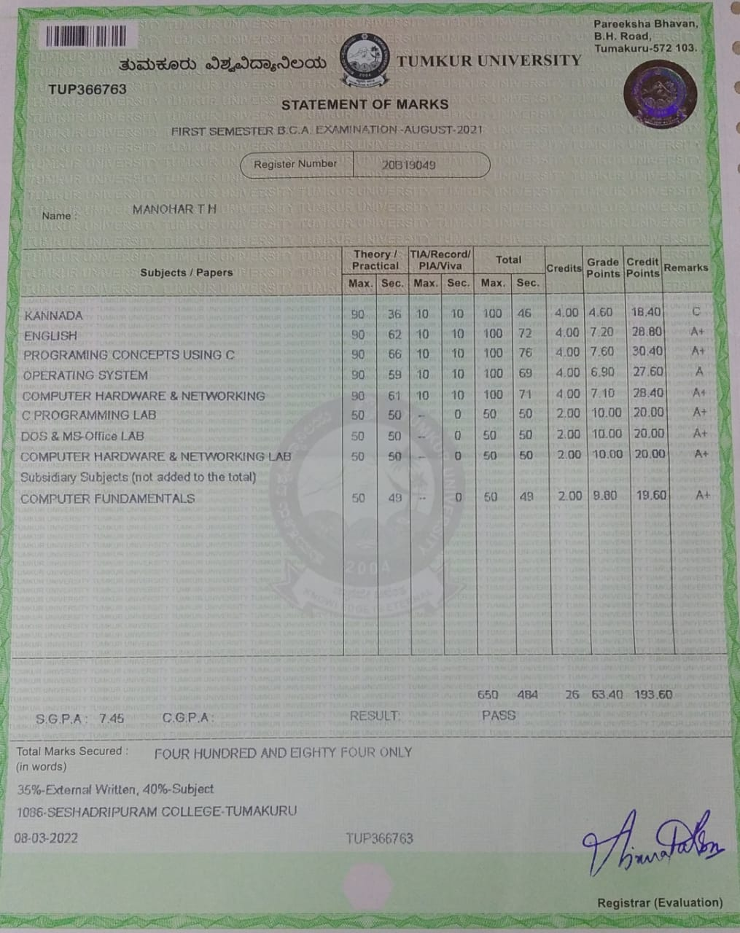

**Second Semester:**

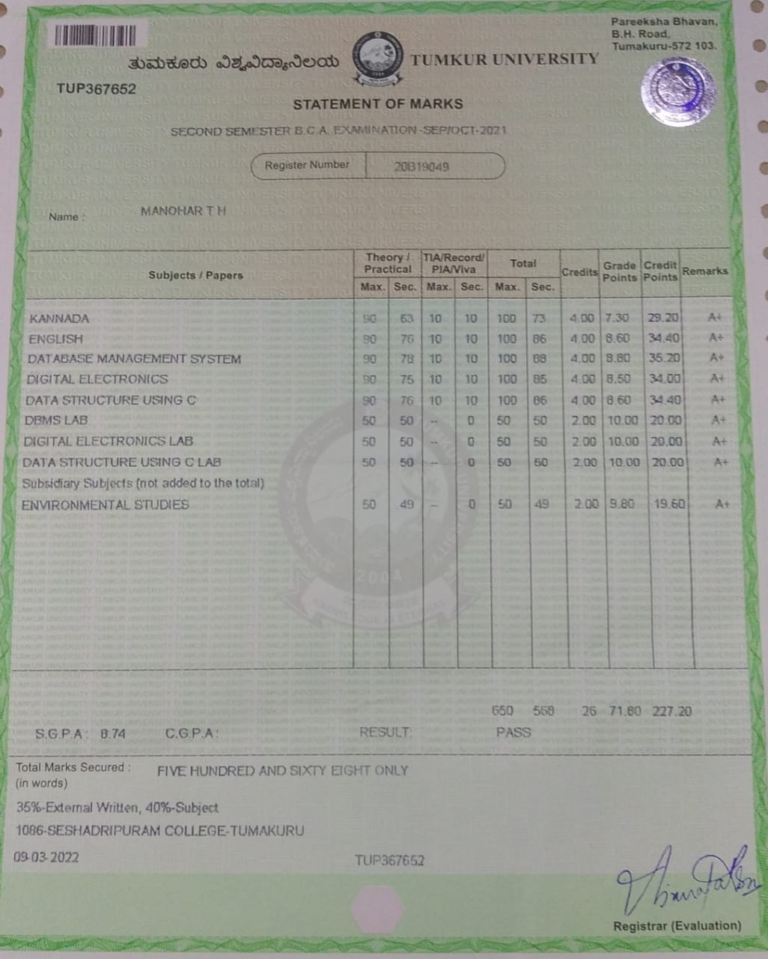

**Third Semester:**

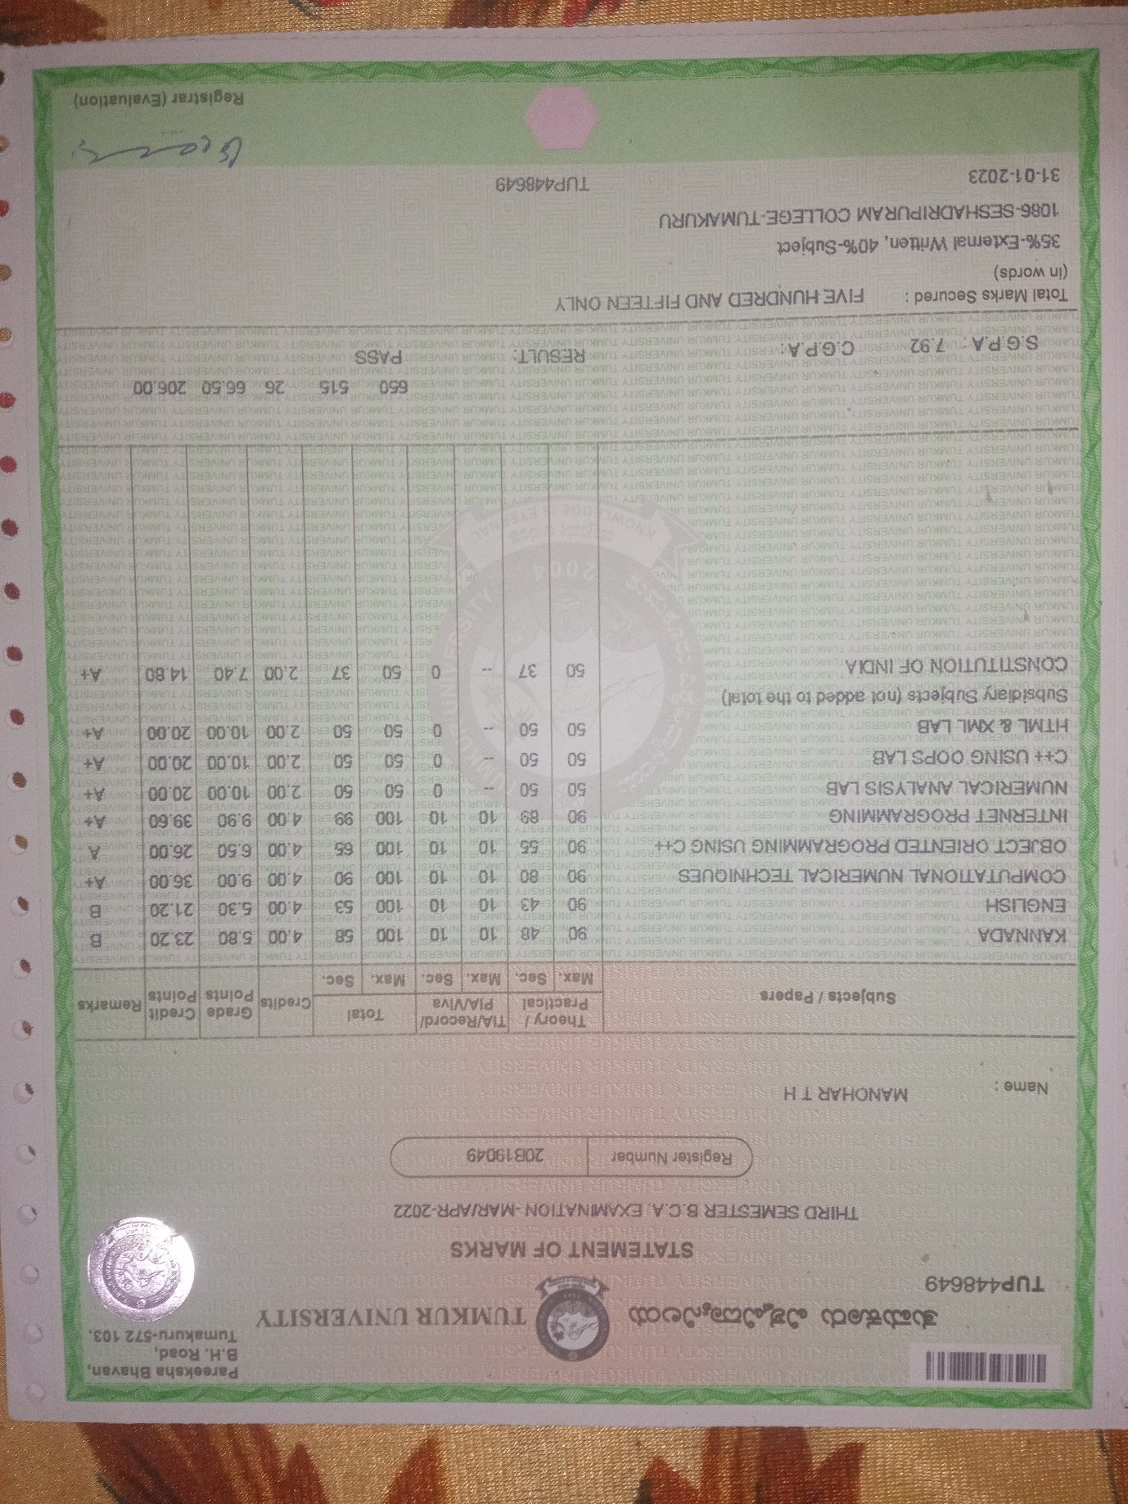

**Fourth Semester:**

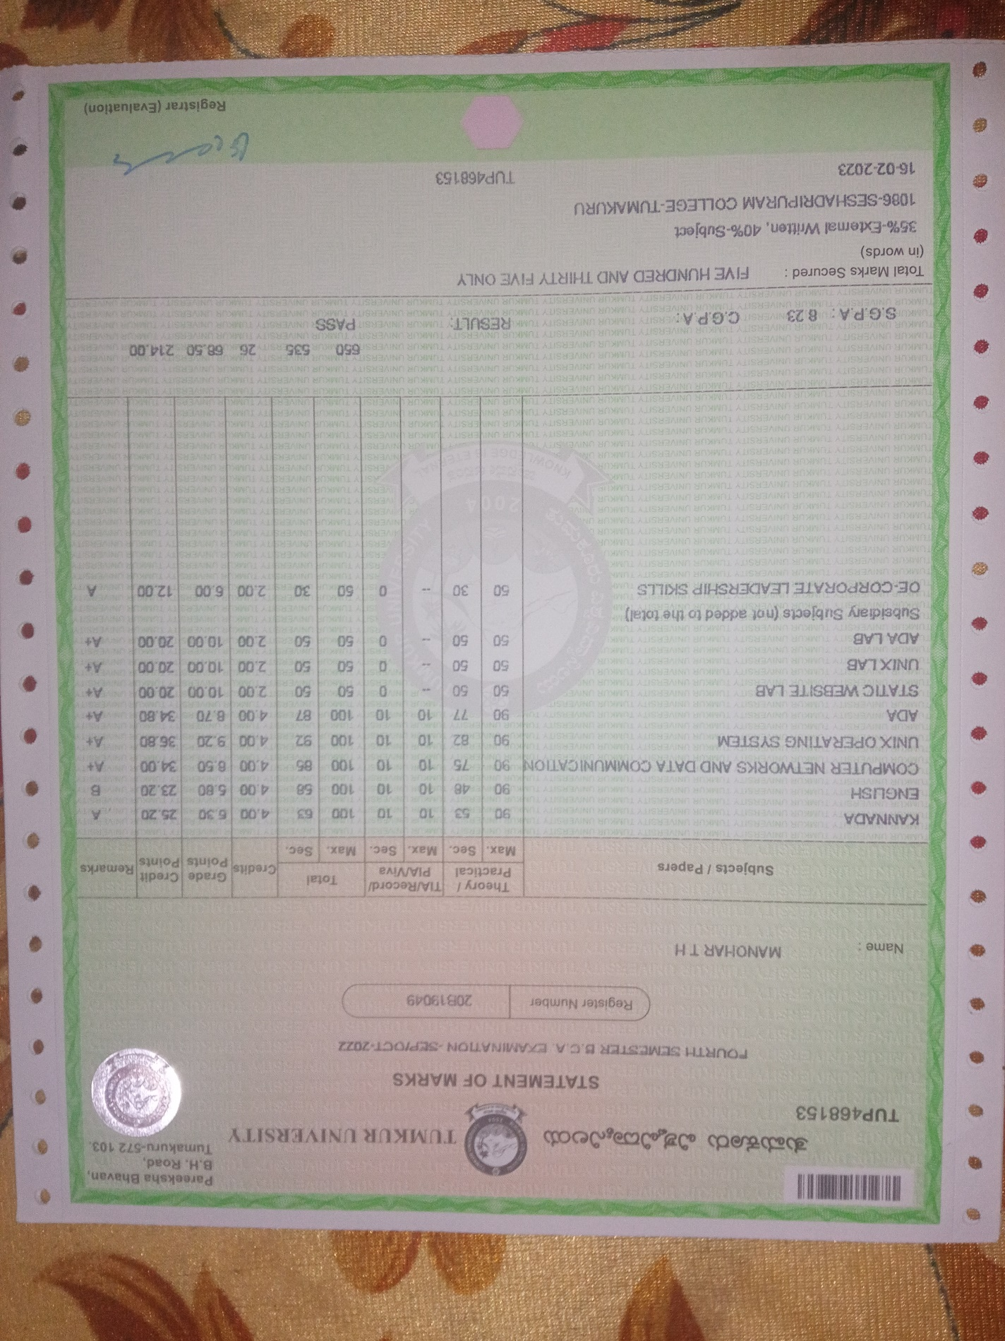

**3. Cover Letter**

Manohar T H

#86, Jodithimasandra,

Madure, Dodabalapur,

Banglore Rural-561204

Date: 17th July 2023

The Hiring Manager,

ABC Cybers.

Bangalore

Dear Sir/Madam,

Sub: Application for the Post of Cybersecurity Engineer.

Ref: advertisement appeared in Deccan Herald dated on 16th July 2023

I am writing to apply for the role of Cybersecurity Engineer at your organization, as advertised in the Deccan Herald on 4th July 2023. I possess the necessary qualifications and experience to excel in this position and contribute to your team.

With a degree in Computer Science and a strong background in cybersecurity practices, I am confident in my ability to effectively protect your organization's sensitive data and systems. I am excited about the opportunity to join your organization known for its excellence and technology advancements.

Please find my enclosed resume for further details on my experience and achievements I would be looking for an opportunity to attend an interview to prove my eligibility for the post

Thank you

Yours faithfully,

Manohar

[Manohar T H]

Encl: 1. Resume

2. Testimonials

**4. PPT’S SNAPSHOTS, SUBJECT WISE**

1. **Presentation Components of Programming in System Software**

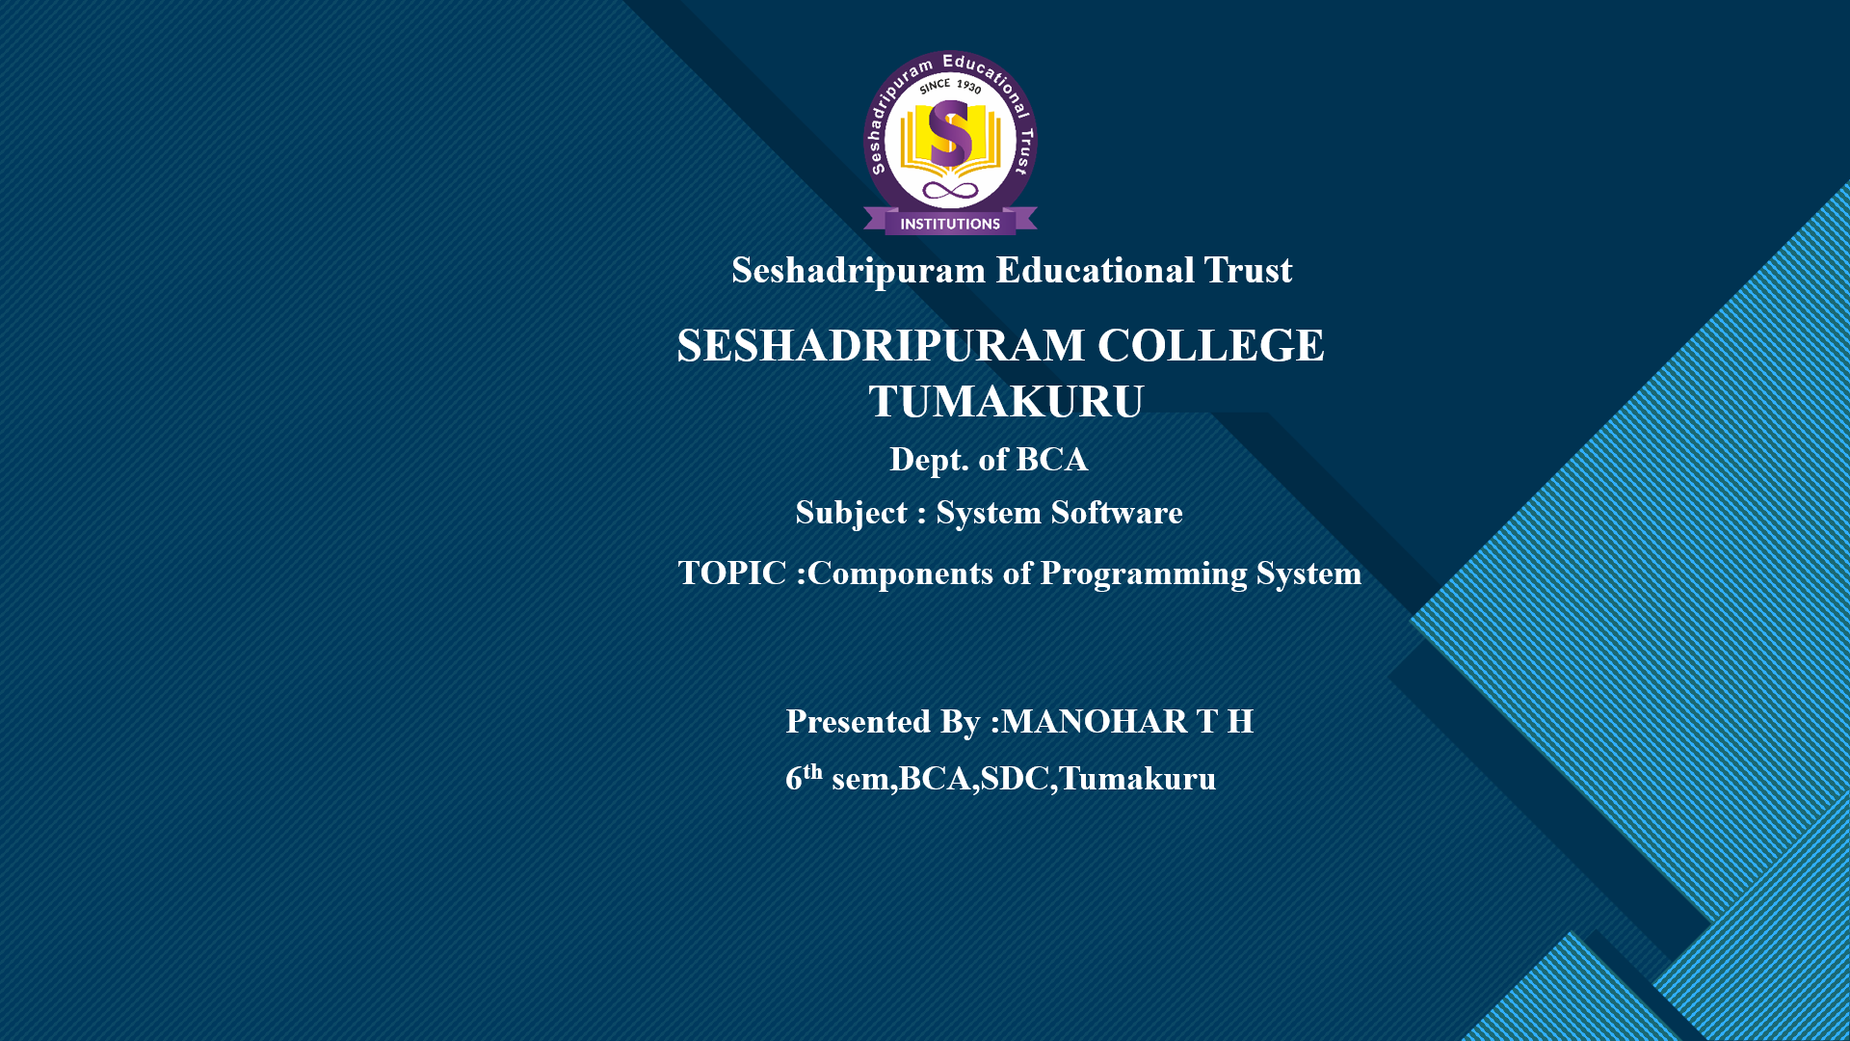

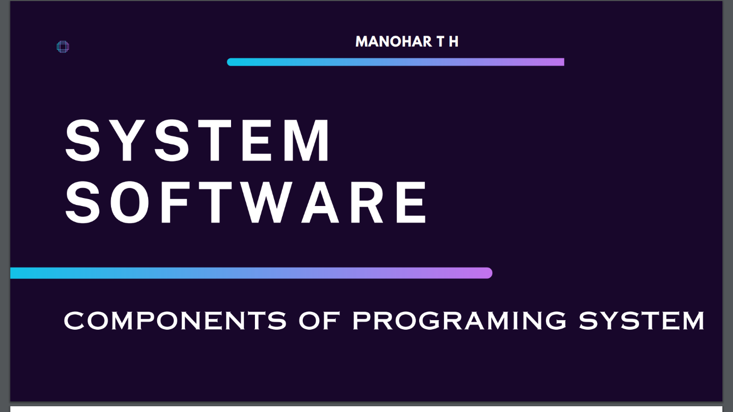

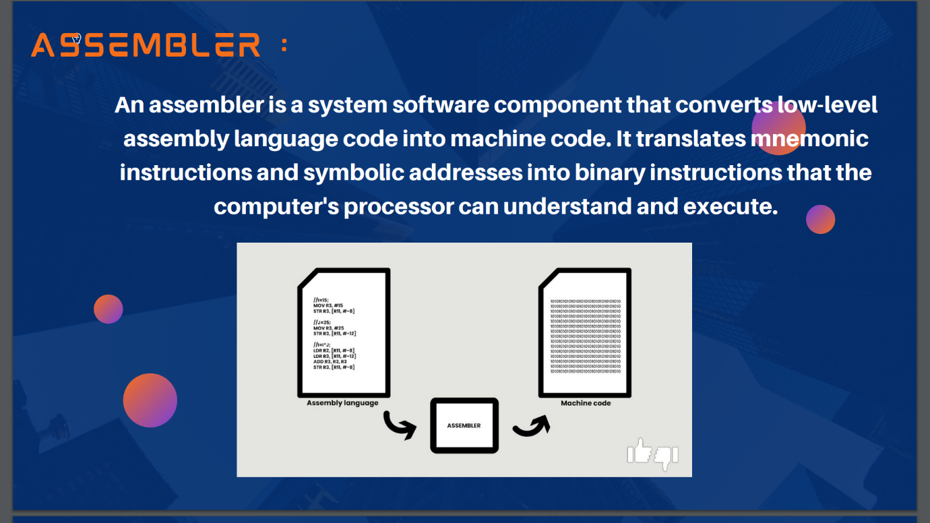

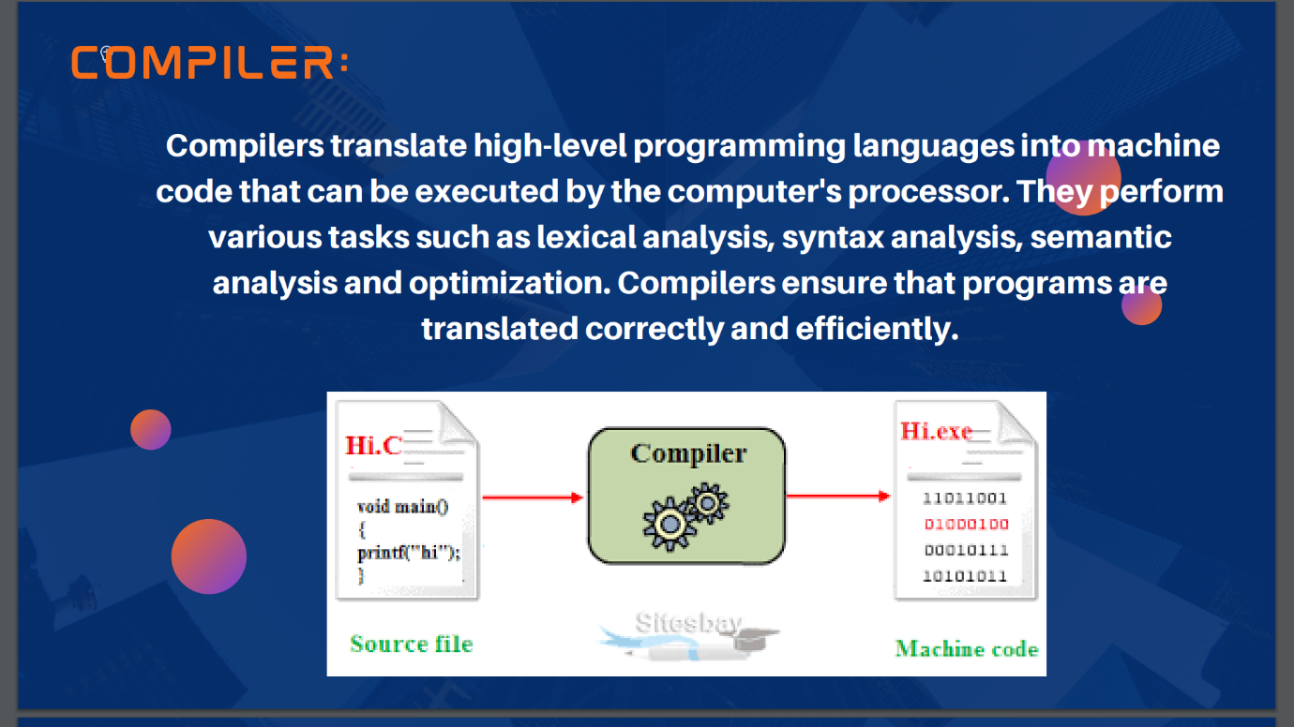

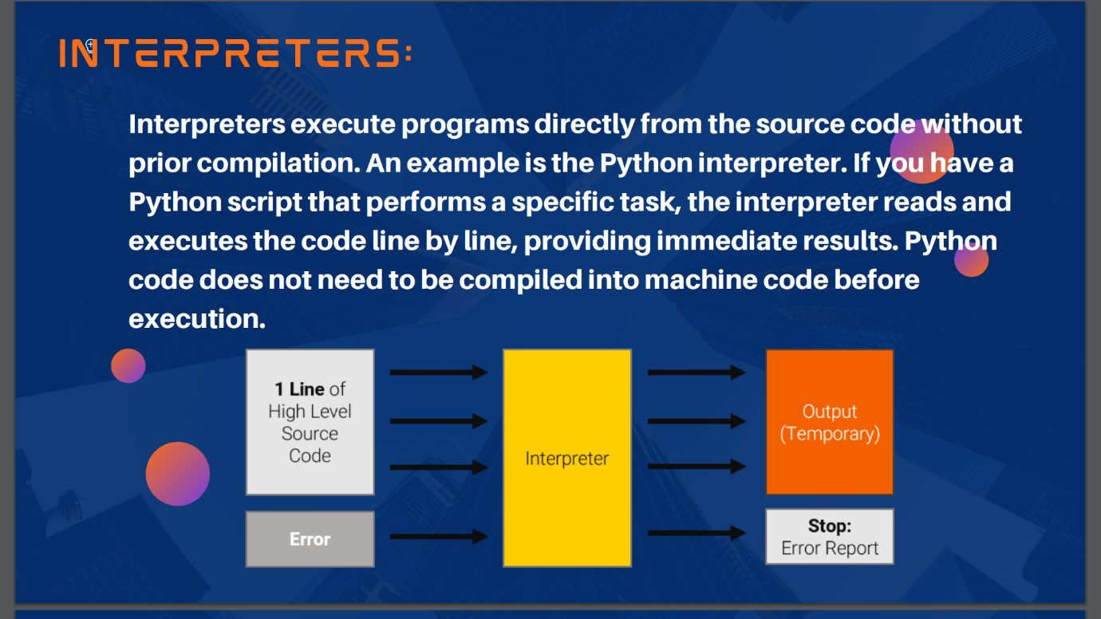

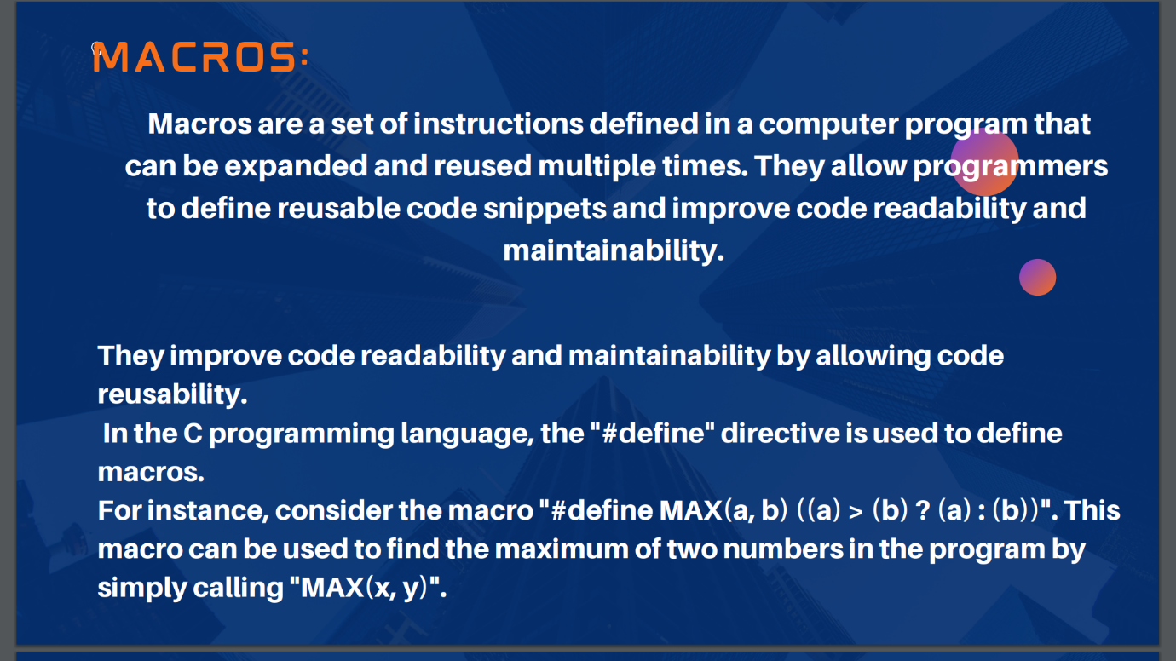

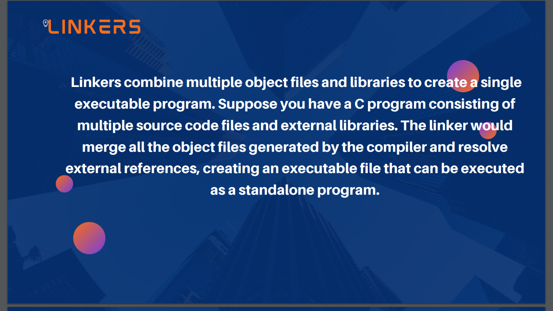

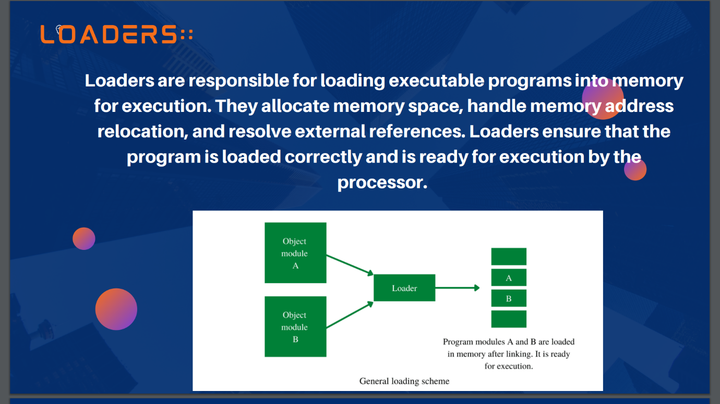

1. **Presentation on Regular Expressions in Python:**

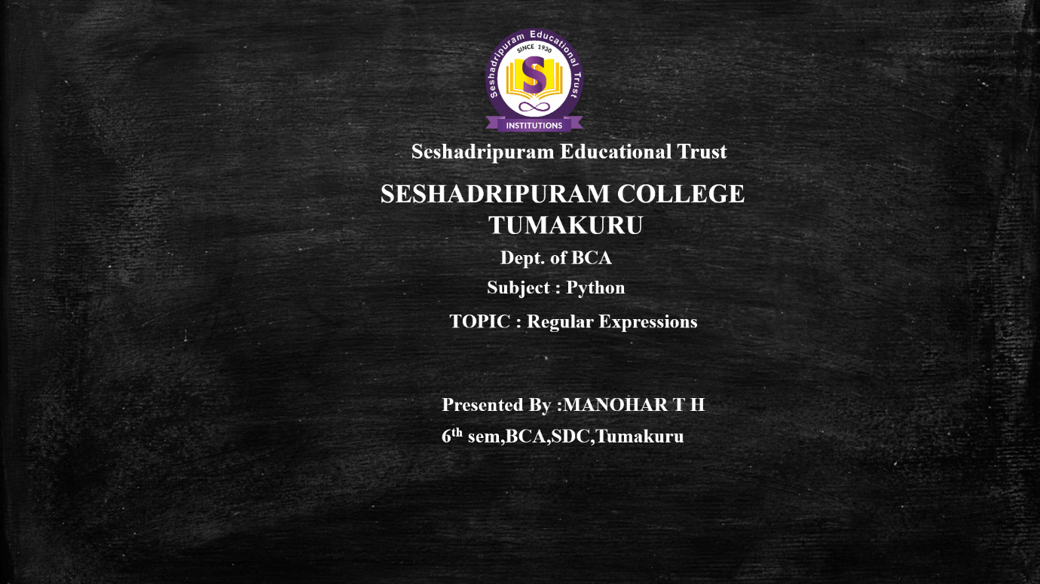

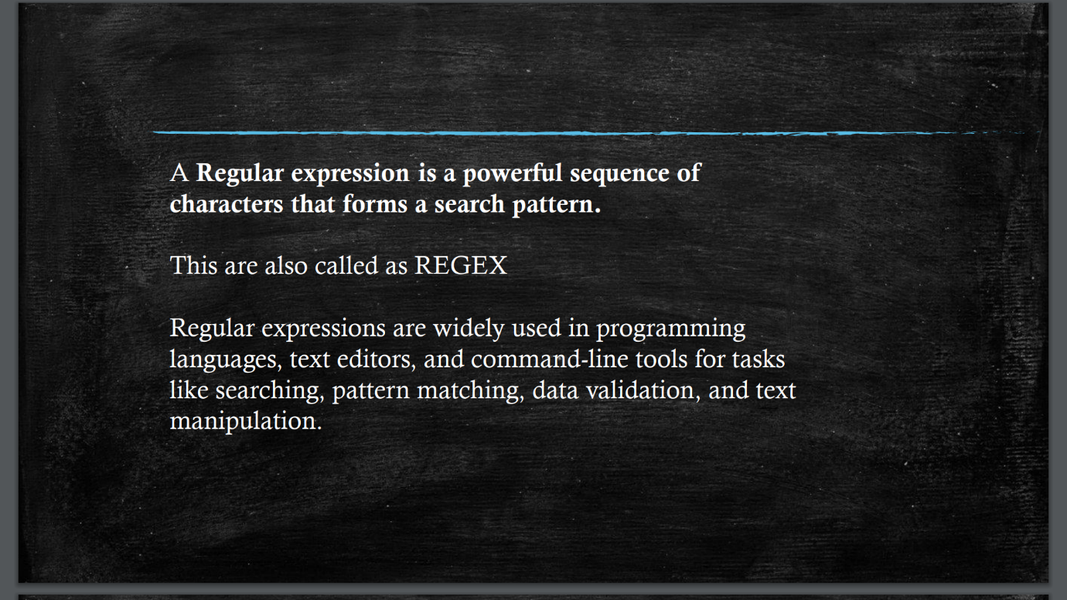

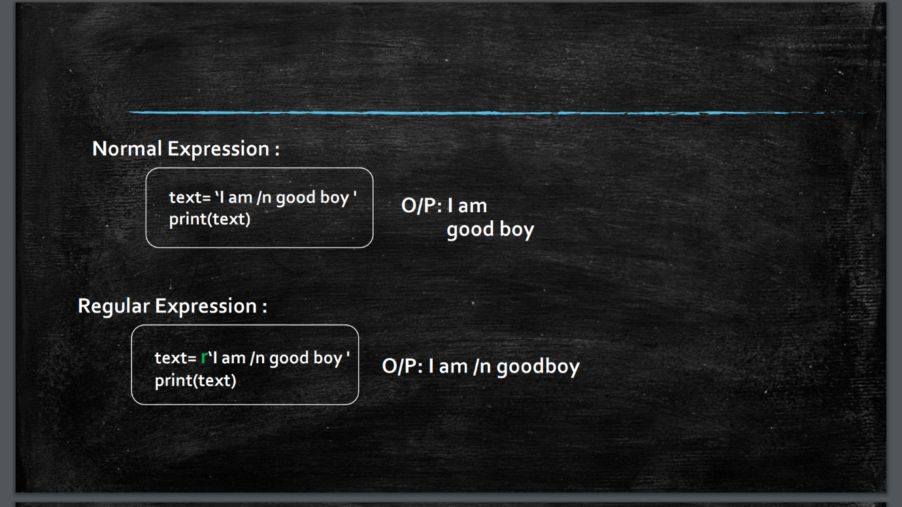

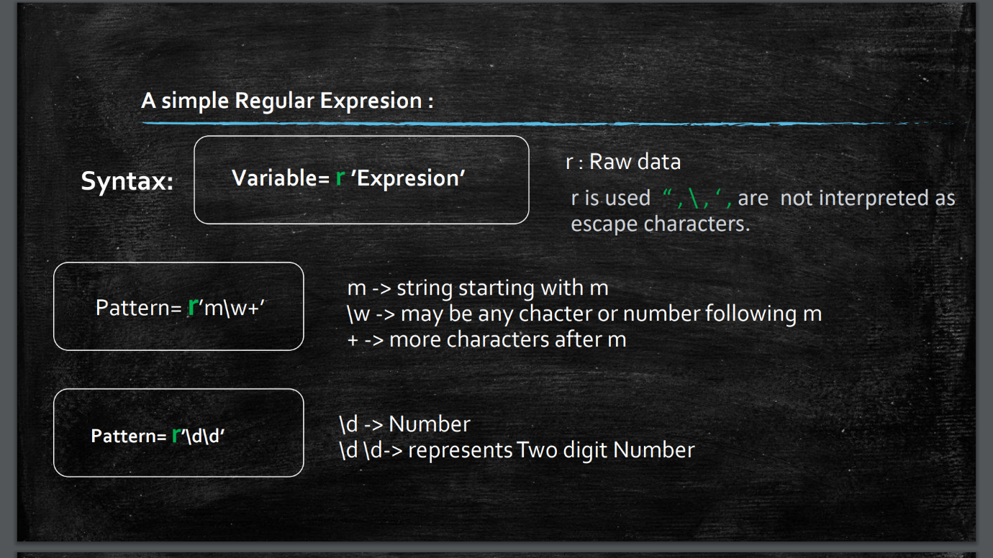

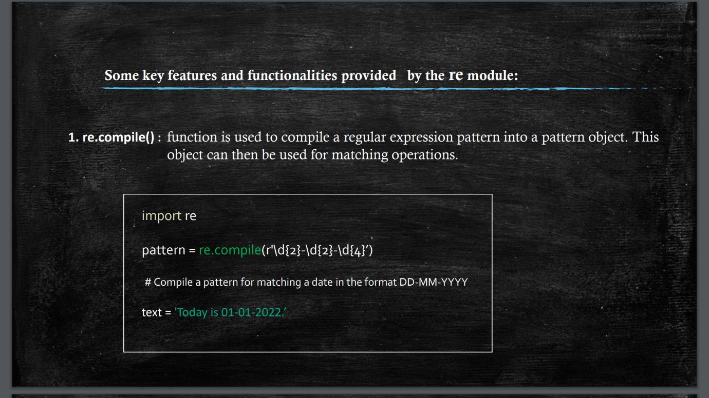

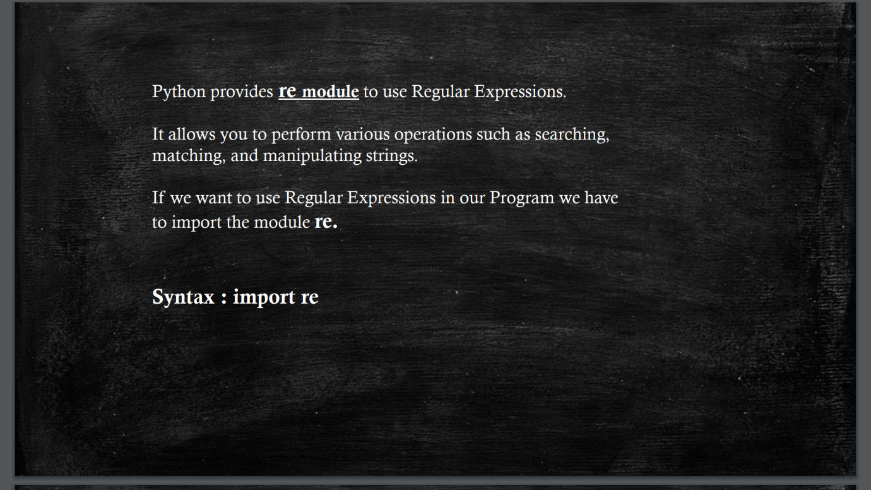

1. **Presentation on Fuzzy Logic in Artificial Intelligence**

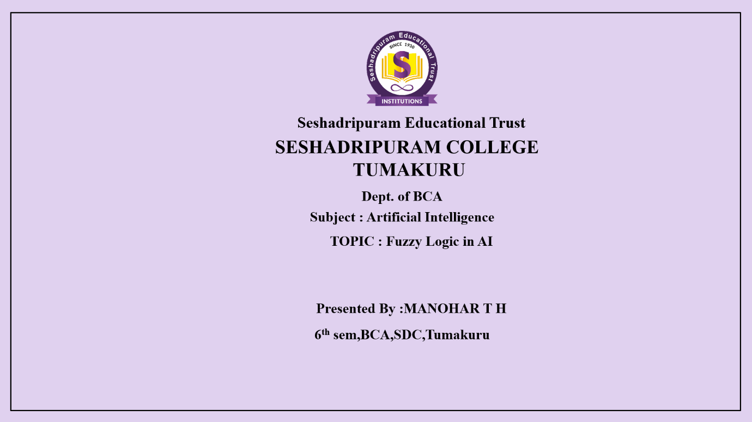

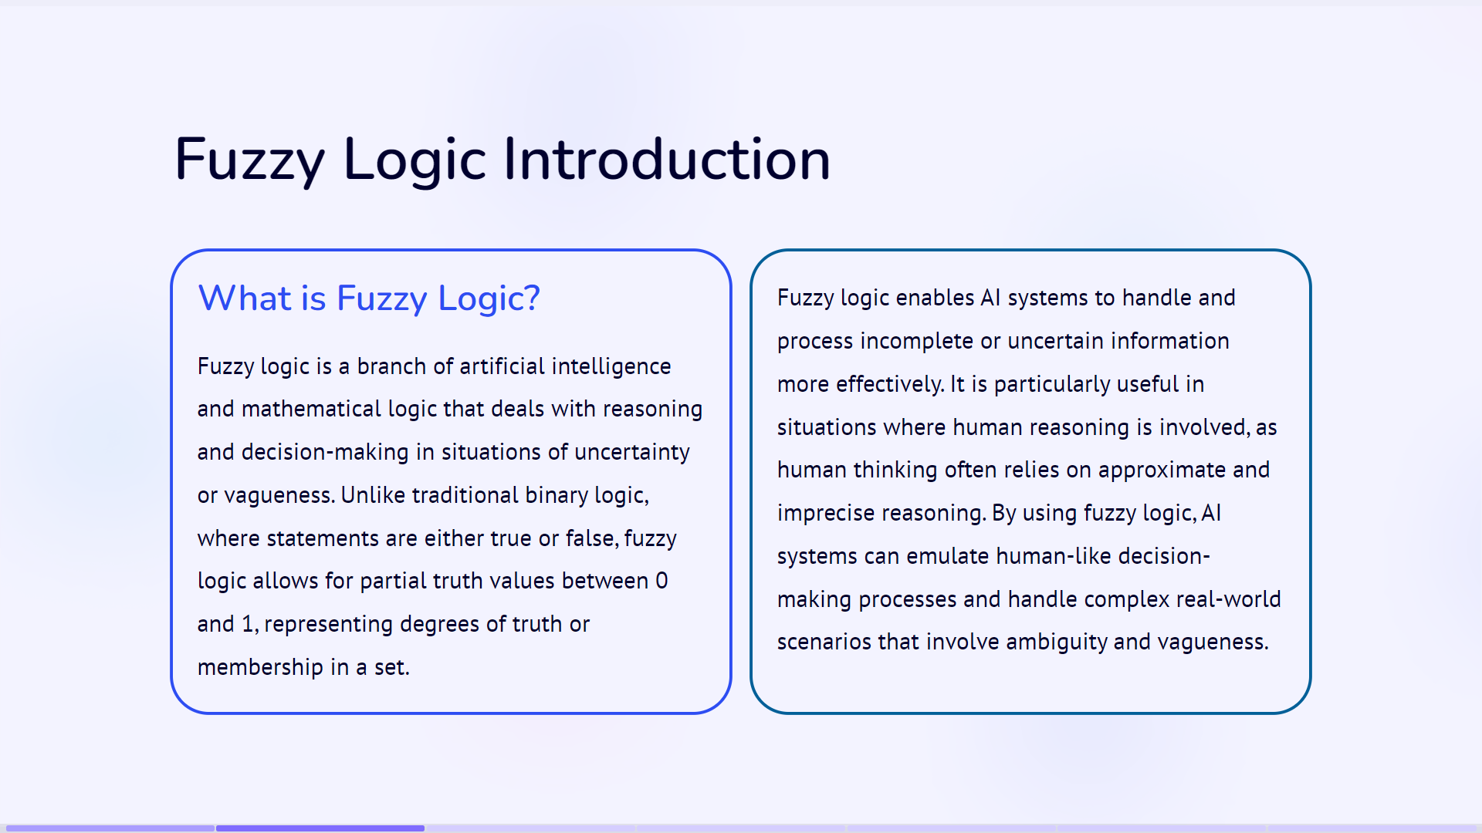

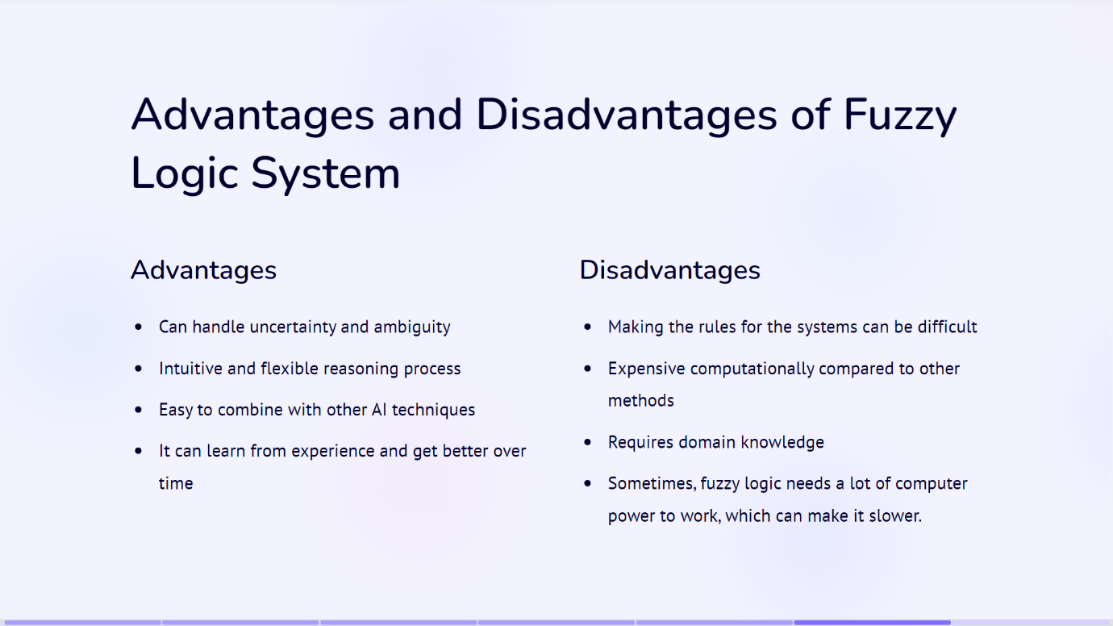

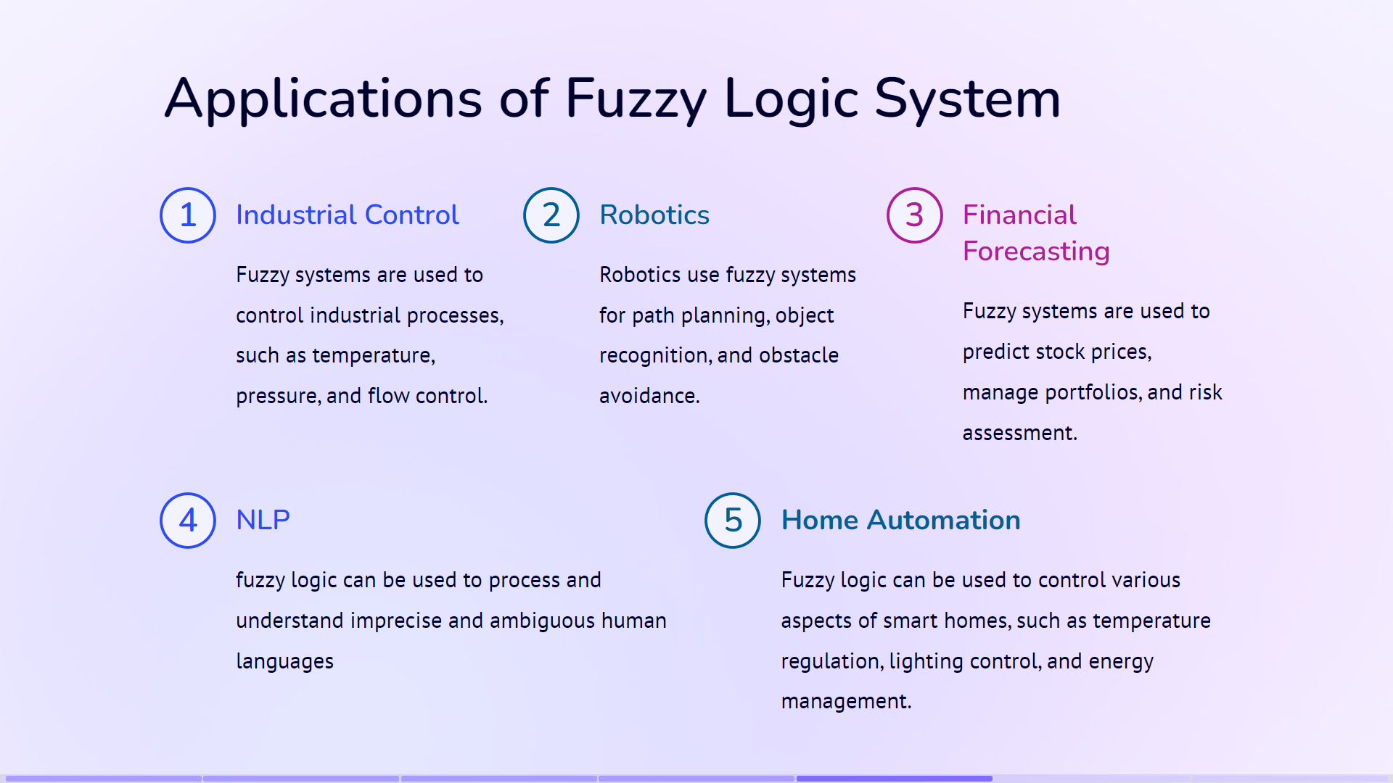

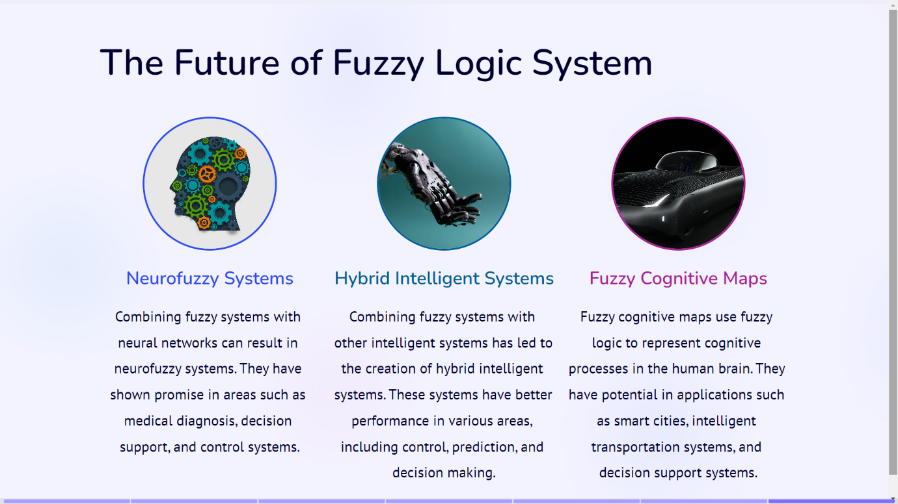

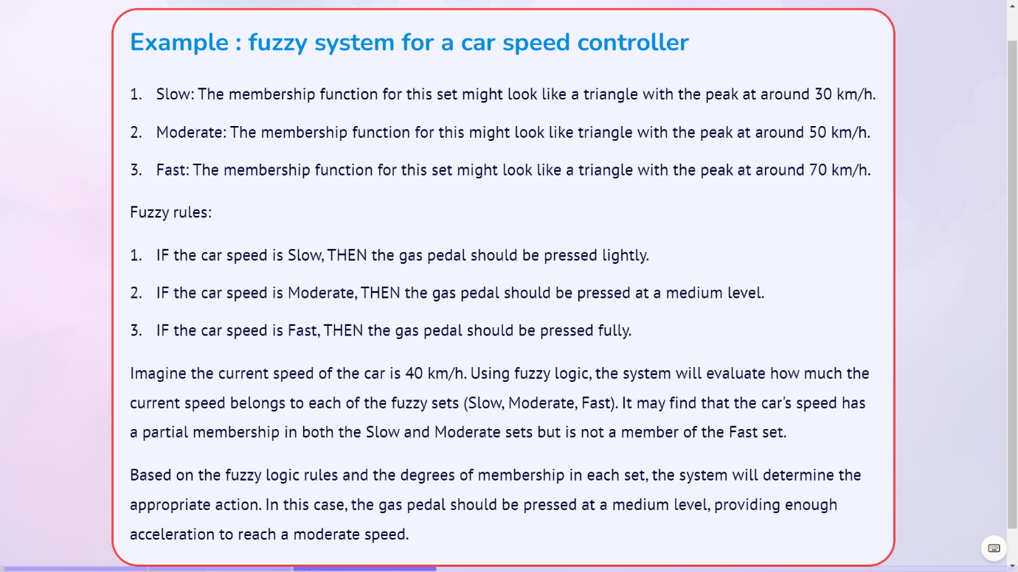

1. **Components in Cryptography:**

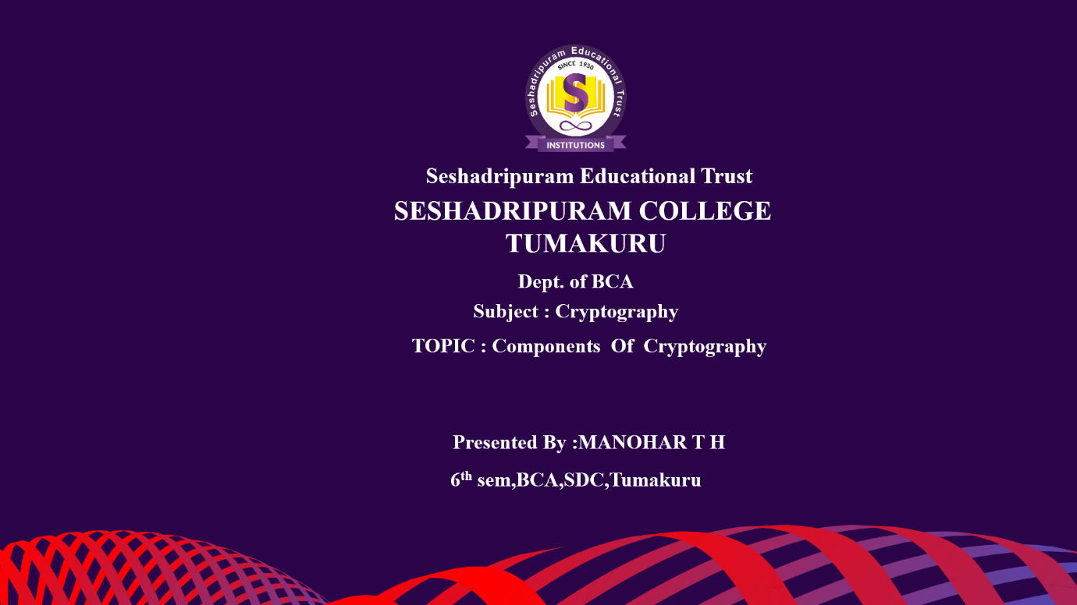

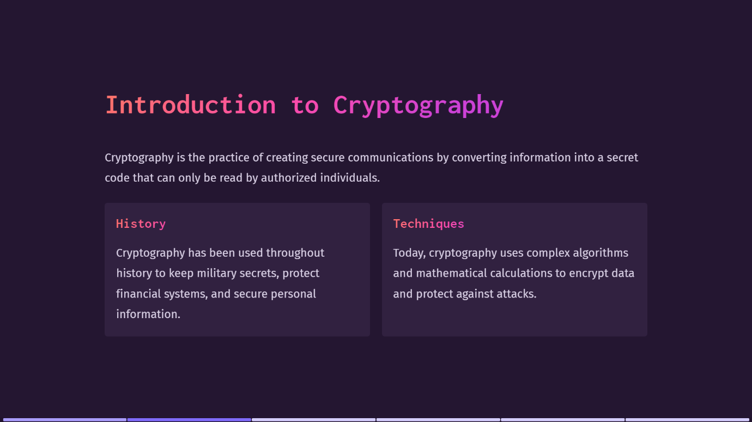

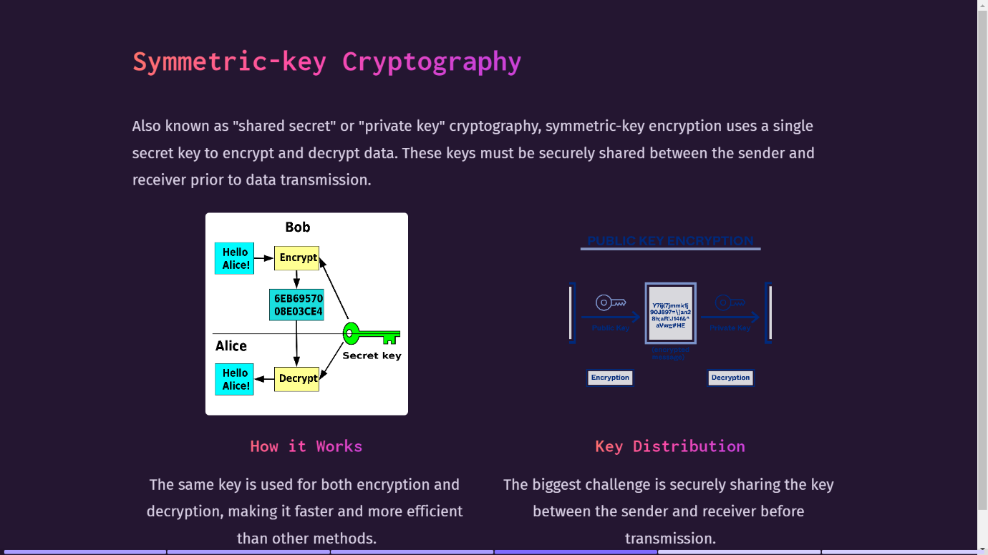

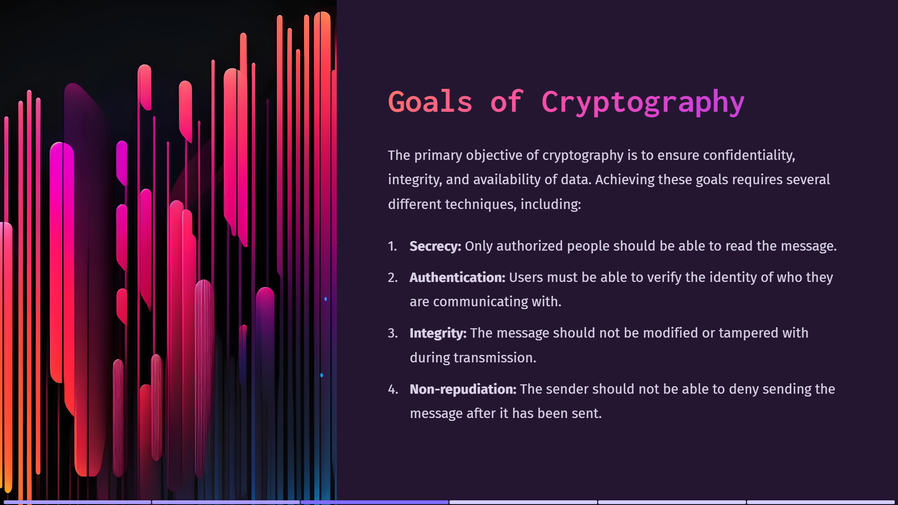

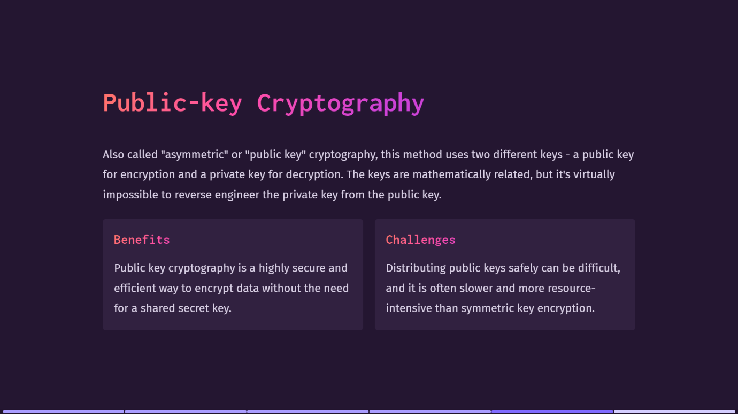

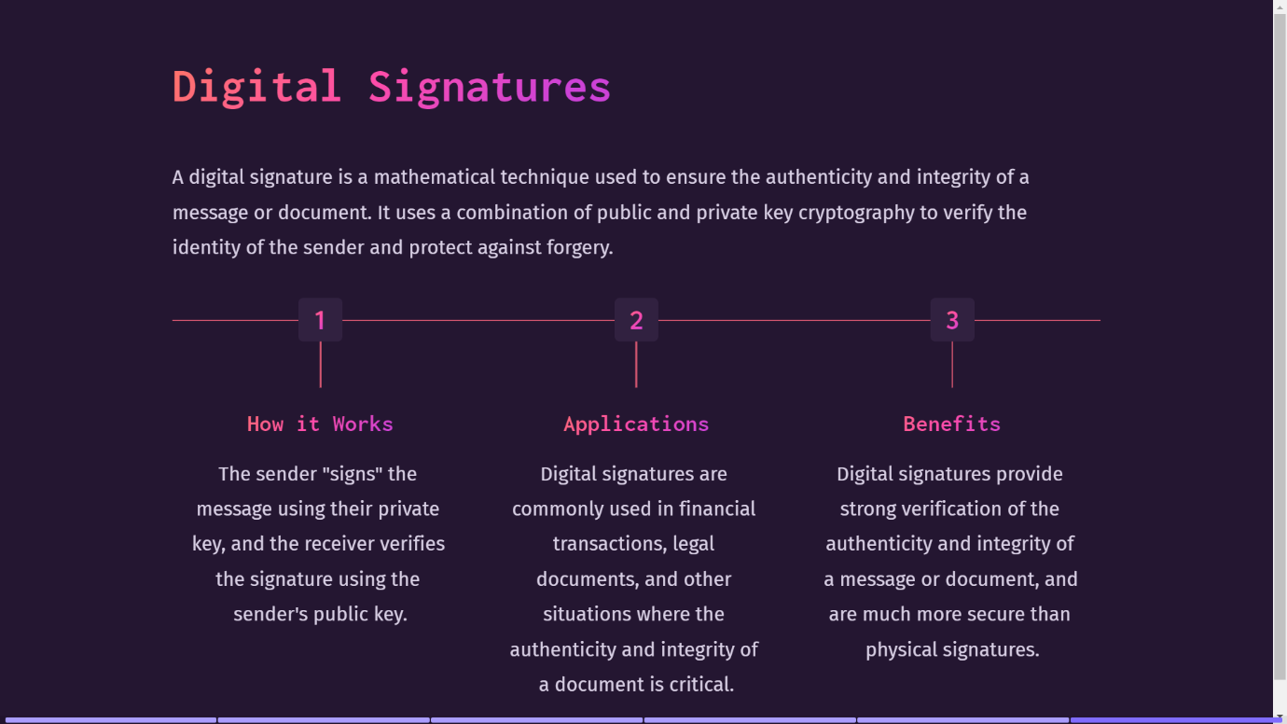

**5. Essay Writing**

An Essay is defined as "a short piece of writing that expresses information as well as the writer's opinion."

Essays are common in elementary, middle, high school and college, and you may even need to write essays in the business world (although they are usually called "reports" at that point).

**Kinds of Essays**

The first step to writing an essay is to decide what kind of essay to write. There are several main structures into which essays can be grouped:

* **Narrative Essays:** Tell a story or impart information about your subject in a straightforward, orderly manner.
* **Descriptive Essays:** Focus on the details of what is going on. For example, if you want to write a descriptive essay about your trip to the park, you would give great detail about what you experienced: how the grass felt beneath your feet, what the park benches looked like, and anything else the reader would need to feel as if he were there.
* **Persuasive Essay:** Convince the reader of some point of view.
* **Comparative Essay:** Compare two or more different things.
* **Expository Essay:** Explain to the reader how to do a given process. You could, for example, write an expository essay with step-by-step instructions on how to make a peanut butter sandwich.

**Every Essay should focus on three:**

**The Introduction**

The introduction is the first part of an essay and it is the one that introduces your subject and presents your stance on it. It is also called an “argument” which means that you will have to explain what led to the decision of writing about that topic.

The introduction should also capture the interest of the readers, so make sure that it is interesting enough so that no one will get bored while reading it. The final sentence should be the one that connects the introduction to the body.

**The Body**

The body can have more paragraphs, and it is up to you to decide how many you need in order to cover the subject. Each paragraph should have solid arguments and you should be able to convince the readers. Don’t forget to offer relevant examples so that you can illustrate your ideas in a better way.

Since you will have more paragraphs, make sure that you transition smoothly from one to another. You might need to use certain phrases, such as “furthermore”, or “moreover” in order to add more supporting arguments.

**The Conclusion**

This is the final part of your essay so it might be more important than you think since it represents the last impression of the reader. The conclusion should sum up your essay and it should be long enough to cover all the important points.

You can also use transitions such as “in conclusion”, or “to sum up”, and then continue by restating your original argument from the introduction.

These tips should help you structure an essay correctly. For more help, you can always choose an essay writer that is willing to help you with your essay. However, you should remember that you should only use such methods if you have no other option. In other situations, it is important that you make an effort on your own.

**Several steps in the essay writing process**.

* Decide what kind of essay to write.
* Brainstorm your topic.
* Do research.
* Develop a thesis.
* Outline your essay.
* Write your essay.
* Edit your writing to check spelling and grammar.

**Some Topics of Essay**

* Your favourite thought leader
* Rise of Al and its impact on Human Civilization
* Startup or established enterprise - your choice for thelong term?
* Recent innovation that excited you
* Your 5-year goal - Professional/Personal
* Your memorable achievement
* How do you define failure?
* Evolution of women in Leadership Roles
* Which social media site do you think will be out of business first?
* Global Climate Change and its side-effects on work-life
* The future of Mobility - Electric vehicles
* The Connected World - How devices speak with each other?
* The Rise of Crypto Currency
* How COVID-19 changed the way businesses are conducted?
* The Rise of Unicorns in India

**Example:**

**TOPIC: The Connected World - How devices speak with each other?**

In today's digital era, we find ourselves immersed in a world where devices seamlessly communicate and share information with one another. This interconnectedness has revolutionized various aspects of our lives, from our homes to industries. So, how do these devices speak to each other?

At the heart of device communication are communication protocols. These protocols are standardized sets of rules that devices follow to exchange data. They define how data is formatted, transmitted, received, and understood, creating a common language for devices to communicate effectively. Wi-Fi, Bluetooth, Zigbee, NFC, and cellular networks are some commonly used communication protocols.

One of the driving forces behind this connected world is the Internet of Things (IoT). Everyday objects, equipped with sensors, are connected to the internet, enabling them to gather data, analyze it, and communicate with other devices. From smart home devices like thermostats and security cameras to wearable fitness trackers and industrial sensors, the IoT ecosystem continues to expand, promising greater convenience and efficiency.

Cloud computing plays a crucial role in device communication. It provides a centralized platform for storing, processing, and analyzing data. Connected devices can offload their data to the cloud, where powerful servers handle complex computations and provide actionable insights. This empowers even resource-constrained devices to access vast computing capabilities and unlock their full potential.

Machine-to-machine (M2M) communication forms the backbone of the connected world. It allows devices to exchange information autonomously without human intervention. In industrial applications, sensors can monitor machinery performance, transmit data to controllers, and trigger automated responses, optimizing operations and reducing downtime.

Wearable devices also contribute to the interconnected landscape. Smartwatches, fitness trackers, and other wearables collect personal data and often form a Personal Area Network (PAN) with smartphones or computers. This facilitates seamless data transfer and synchronization between devices, offering users a unified and integrated experience.

While the connected world brings numerous benefits, it also raises important security and privacy considerations. With devices constantly exchanging data, there is an increased risk of data breaches and unauthorized access. Implementing robust encryption, authentication mechanisms, and regular software updates are crucial to safeguard user information and maintain trust in connected systems.

In conclusion, living in a connected world means devices communicate through communication protocols, leveraging the power of IoT, cloud computing, and M2M communication. This interconnectivity has transformed our lives, offering convenience, efficiency, and personalized experiences. However, ensuring security and privacy is essential to foster a safe and reliable digital environment. By embracing this technology responsibly, we can harness its full potential and create a smarter, more interconnected future.

**6. Letter Writing**

A letter is a written message that can be handwritten or printed on paper. It is usually sent to the recipient via mail or post in an envelope, although this is not a requirement as such. Any such message that is transferred via post is a letter, a written conversation between two parties.

Now that E-mails and texts and other such forms have become the norm for communication, the art of letter writing has taken a backseat. However, even today a lot of our communication, especially the formal kind, is done via letters. Whether it is a cover letter for a job, or the bank sending you a reminder or a college acceptance letter, letters are still an important mode of communication. Which is why it is important that we know the intricacies of letter writing?

**Types of letters:**

* **Formal Letter:** These letters follow a certain pattern and formality. They are strictly kept professional in nature, and directly address the issues concerned. Any type of business letter or letter to authorities falls within this given category.
* **Informal Letter:** These are personal letters. They need not follow any set pattern or adhere to any formalities. They contain personal information or are a written conversation. Informal letters are generally written to friends, acquaintances, relatives etc.
* **Business Letter**: This letter is written among business correspondents, generally contains commercial information such as quotations, orders, complaints, claims, letters for collections etc. Such letters are always strictly formal and follow a structure and pattern of formalities.
* **Official Letter**: This type of letter is written to inform offices, branches, subordinates of official information. It usually relays official information like rules, regulations, procedures, events, or any other such information. Official letters are also formal in nature and follow certain structure and decorum.
* **Social Letter**: A personal letter written on the occasion of a special event is known as a social letter. Congratulatory letter, condolence letter, invitation letter etc are all social letters.
* **Circular Letter**: A letter that announces information to a large number of people is a circular letter. The same letter is circulated to a large group of people to correspond some important information like a change of address, change in management, the retirement of a partner etc.
* **Employment Letters**: Any letters with respect to the employment process, like joining letter, promotion letter, application letter etc.

**Letter Writing Tips**

Now that we have learned the basics of communicating via letters and the types of letters as well, let us focus on some tips for the actual letter writing.

### 1] Identify the type of letter

This obviously is the first step of the letter writing process. You must be able to identify the type of letter you are to be writing. This will be dictated by the person the letter is addressed to and the information that will be conveyed through the letter. Suppose you were writing to the principal of your college to ask for leave, this would be a formal letter. But say you were writing to your old college professor catching up after a long time. Then this would be a personal (informal) letter.

### 2] Make sure you open and close the letter correctly

Opening a letter in the correct manner is of utmost importance. Formal letters open with a particular structure and greeting that is formal in nature. Informal letters can be addressed to the person’s name or any informal greeting as the writer wishes.Even when closing the letter, it must be kept in mind what type of letter is being written. Formal letters end respectfully and impersonally, whereas informal letters may end with a more personal touch.

### 3] Establish the main intent of the letter

Once you start writing, make sure to get to the point as soon as possible. Especially in formal letters, it is important to immediately make clear the purpose of the letter.

### 4] Be careful of the language

A letter is always supposed to be polite and considerate. Even if it is a complaint letter, the point must be made in a careful and courteous manner. So it is necessary to use polite expressions and civil language in all types of letters.

### 5] Length of the letter

And the other important factor to be considered is the length of the letter you are writing. It should be kept in mind that formal letters are generally to the point, precise and short. Lengthy formal letters tend to not have the desired effect on the reader. The length of an informal letter is determined by the message in the letter and the relation to the recipient.

**Formal Letter**

A formal letter is one written in a formal and ceremonious language and follows a certain stipulated format. Such letters are written for official purposes to authorities, dignitaries, colleagues, seniors etc and not to personal contacts, friends or family. A number of conventions must be adhered to while drafting formal letters. So let us take a look at a sample format of a formal letter.

**Format of a Formal Letter**

As we said earlier, a formal letter must follow certain rules and conventions. Such a format helps in relaying the information in a professional way. It must be remembered that there are various such formats for formal letters that people follow. The one explained here is the one most commonly used for formal communication these days.

### Sender’s Address

The sender’s address is usually put on the top right-hand corner of the page. The address should be complete and accurate in case the recipient of the letter wishes to get in touch with the sender for further communication.

### Date

The sender’s address is followed by the date just below it, i.e. on the right side of the page. This is the date on which the letter is being written. It is important in formal letters as they are often kept on record.

### Receiver’s Address

After leaving some space we print the receiver’s address on the left side of the page. Whether to write “To” above the address depends on the writer’s preference. Make sure you write the official title/name/position etc of the receiver, as the first line of the address.

### Greeting

This is where you greet the person you are addressing the letter to. Bear in mind that it is a formal letter, so the greeting must be respectful and not too personal. The general greetings used in formal letters are “Sir” or “Madam”. If you know the name of the person the salutation may also be “Mr. XYZ” or “Ms. ABC”. But remember you cannot address them only by their first name. It must be the full name or only their last name.

### Subject

After the salutation/greeting comes the subject of the letter. In the centre of the line write ‘Subject” followed by a colon. Then we sum up the purpose of writing the letter in one line. This helps the receiver focus on the subject of the letter in one glance.

### Body of the Letter

This is the main content of the letter. It is either divided into three paras or two paras if the letter is briefer. The purpose of the letter should be made clear in the first paragraph itself. The tone of the content should be formal. Do not use any flowery language. Another point to keep in mind is that the letter should be concise and to the point. And always be respectful and considerate in your language, no matter the subject of your letter.

### Closing the Letter

At the end of your letter, we write a complimentary losing. The words “Yours Faithfully” or “Yours Sincerely” are printed on the right side of the paper. Generally, we use the later if the writer knows the name of the person.

### Signature

Here finally you sign your name. And then write your name in block letters beneath the signature. This is how the recipient will know who is sending the letter.

**Example:**

#86 Jodi Thimasandra,

Madure,Dodabalapura

Bangalore Rural-561204

17th July 2023

To

The Hiring Manager,

Company XYZ,

Banglore-576 101

Respected Sir,

Sub: Application for Frontend Developer Position

Ref: Frontend Developer, Advertised in Times Now dated on 16th July 2023

I am writing to express my interest in the Frontend Developer position that I saw advertised on Times Now. I have been working as a Frontend Developer for the past 3 years, and I have a strong understanding of HTML, CSS, and JavaScript.

In my previous role at ABC, I was responsible for developing and maintaining the company's website. I also worked on a number of internal web applications,I am confident that I have the skills and experience that you are looking for in a Frontend Developer. I am also excited about the opportunity to work in your company. I have attached a copy of my resume as well as my portfolio showing examples of my work.

Sincerely,

Manohar

[Manohar T H]

**Informal Letter**

Informal letters are written to close acquaintances of the writer, their friends, family, relatives etc. Since they are written to close relations the letters have an informal and personal tone. Casual language is used while writing informal letters. And sometimes the letters may even have an emotional undertone.

Informal letters are mainly used for personal communication. So they do not have to follow any specific pattern, format or conventions. They can be written as per the writer’s wishes and the requirement of the situation. So the letter is written in a personal fashion in casual unassuming language.

**Format of Informal Letter**

As we discussed earlier there is no set format when writing an informal letter. But there is a general pattern, some conventions that people usually follow. We will be looking at this pattern and certain tips on how to write effective and attractive informal letters. These can act as guidelines when you are drafting a letter, they are not hard and fast rules. Let us begin.

### Address

The first thing to write is your address, i.e. the address of the writer. We usually write the address on the left-hand side of the page at the very top. The address should be accurate and complete. Even when writing to close friends or relatives the address must be written, so they can reply back to the letter with ease. If the recipient of the letter is in another country, do not forget to write your country as well in the address.

### Date

Next just below the address we write the date. This allows the reader to have a reference as to when the address was written. He can then relate better to the contents of the letter.

### Greeting

Now since you know the person you are writing to, the greeting can be informal as well. If it is a friend or someone close to your age you can greet them by their first name, like “Dear Alex”. If you are writing to your relative like your mother/father/aunt/uncle etc, you may greet them as such, for example, “Dear Mom”. And if you are writing to an elder person, someone you respect greatly you can address them as Mr or Mrs. Like say for example you were writing a congratulatory letter to your teacher, it can be addressed as “Dear Mrs. Alex”.

### Introduction Paragraph

And now we begin writing the actual letter. The introductory [paragraph](https://www.toppr.com/guides/english/writing/paragraph/) sets the tone for the whole letter. You might begin by asking the recipient about their well being. Or you may say that you hope the letter finds them in good health and great spirits. The opening of informal letters should be casual and comforting. It must not be formal and direct as in business letters.

### Body of the Letter

The letter overall should maintain a friendly tone. But you have to adjust the language and the wordings according to who you are writing to. With a friend, you can afford to be very casual and flippant even. But if you are writing to an elder relative, you must be extremely respectful and considerate.

One way to determine the tonality of your letter is to remember how you talk to the person in a conversation. And then apply the same syntax and sentiments to the letter.

### Conclusion

In the conclusive paragraph sum up the reason for writing the letter, i.e. summarize the letter. Say a meaningful and affectionate goodbye to the reader. And do not forget to invite the reader to write back or reply to your letter. It shows an intention to keep the conversation going.

### Signature

There is no one way to sign off informal letters. Since they do not follow a strict format, you may sign off as you please. Some commonly used phrases are

**Example:**

#86 Jodi Thimasandra,

Madure,Dodabalapura

Bangalore Rural-561204

17th July 2023

Dear Precious Friend,

Hey there, my incredible Best Friend. I hope this letter finds you in high spirits and with a smile on your face. I just wanted to take a moment to let you know how much you mean to me and how grateful I am to have you as my Friend.

First things first, I want you to know how grateful I am to have you in my life. You're more than just a friend; you're my partner in crime, my confidante, and the one who always knows how to cheer me up when life gets tough.

Remember all those times we laughed so hard we couldn't breathe? Or those moments we cried on each other's shoulders, knowing we had each other's backs? Those are the moments that make our bond unbreakable, and I'm so thankful for every single one of them.

Thank you for being the most fantastic, supportive, and fun person in my life. You bring so much joy and happiness, and I'm grateful every day for our friendship, Take care, stay awesome, and keep shining bright, just as you always do.

With all my love and friendship,

Manu

**7. Group Discussion**

Group Decision if formed by combining two words, ie group and discussion. Here, group means a number of people or things that are put together considered as a unit whereas the word discuss is derived from the latin word discutere, which means shake or strike. Thus discussion refers to examine the topic thoroughly to reach a conclusion. Collectively, it is called Group Discussion which means the Exchange of ideas by participated candidates on a specific subject or topic. The whole concept is to bring Collectively a unit of people on a common platform to share their ideas.

**What is Group Discussion?**

An average GD usually features 10 to 15 participants. The GD process begins by the announcement of the topic to the group, which is (usually) followed by a preparation time of 3 to 5 minutes. More than 5 minutes’ prep time may be given only if the GD is a case-study discussion, and has a long case statement.

At the end of the prep time, the panel signals the group to commence the discussion, and from then on plays the role of a non-participating observer. This means that the discussion is not moderated or ‘anchored’ by a panellist. The group members must discuss the topic as they deem appropriate without any kind of suggestion from the panel. The panel expects no particular order of speakers to be followed nor a minimum or maximum duration of speaking to be followed by individual participants.

The average duration of most GDs is 15 minutes (not including the prep time). In some exceptional cases (such as IIFT), the GD may continue for up to 45 minutes. One must remember that the longer the GD goes on, the more seriously the panel looks at the quality of the content (facts, analysis, explanation and argument) of the participant.

**What are the Types of Group Discussion?**

Most Group Discussions can be divided into 3 kinds:

1. **Topical Group Discussions**, which are based on current affairs or ‘static’ matters – for example, a GD on the topic of the recent demonetisation of Rs 500 and Rs 1000 notes would be the former, whereas a GD on whether India should adopt a presidential model of democracy would be the latter, as it has no limitation of a time frame.
2. **Case-studies**: which present the group with a complex business situation that requires a decision to be made. Such cases usually have multiple problems embedded in the given situation, and both the individual participants and the group are required to analyse the situation, identify the problems, and suggest a way out.
3. **Abstract Group Discussions**: which are called so because they offer us no definite framework of the topic, and hence no definite direction to take in the discussion. Instead, the participants are required to interpret the topic in their own ways and demonstrate innovative thinking in doing so. Such topics could be single-worded, such as ‘Blue’, or a short cryptic sentence, or even an image. Contrary to popular perception, no one kind of GD is necessarily easier or more difficult than any other, as the quality of response in any case depends largely on the preparation of the individual and the way they generally think.

## **What is Evaluation Criteria in the Group Discussion?**

The evaluation of participants happens in two broad perspective: **Individual qualities and group skills**. Individual Qualities refer to the competencies that you may demonstrate in or outside the context of a group. They include the following:

1. **Content:** What you say during the discussion is looked into from two perspectives – relevance and comprehensiveness. It is possible that a participant has talked a great deal in a GD, but he or she may have deviated from the topic significantly, in which case the content is deemed largely irrelevant without the possibility of further evaluation. If the content has been relevant to the topic, the panel examines whether your treatment of the topic is superficial or in-depth, distinction we shall discuss in detail in the next few posts.
2. **Analytical skills:** The panel is of course interested in your facts, but they also like to see whether or not you can explore the ‘why’ and the ‘how’ of the subject matter. This is put to the sternest test in a case-study topic.
3. **Reasoning skills:** The panel looks at how you support your standpoints, and how you respond to those of the others, how effectively you can ‘strengthen or weaken’ an argument, how logical you are in your overall approach to the topic.
4. **Organisation skills:** You may have the facts, the supports, the explanations, but are you able to present them in the right order so as to maximise the impact of your good content? The panel wants to examine this.
5. **Communication skills:** You may have exhibited all the skills stated above, but can you get your point across to someone in a simple (not simplistic) language they understand, with relevant illustrations they can identify with?
6. **Creativity:** Are you able to bring to the table a novel perspective on the topic? Can you look at a problem differently from ten other participants and suggest a path-breaking solution? Can you interpret an abstract topic in ways the others cannot? If yes, the panel looks at you as someone with one of the rarest of human qualities.

You may have observed that the above skills and qualities can also be directly applied in the evaluation of the [WAT](https://www.handakafunda.com/how-to-approach-group-tasks-extempore-pictorial-wat/)response.

On the other hand, the **group skills** refer to those skills which can only be evaluated in the context of a group. They include the following:

1. **Listening skill:** The panel constantly observes whether or not every participant is listening to the discussion. In my experience, most participants are concerned only with speaking, and feel that they are done with the job as soon as they have spoken, which is contrary to the spirit of a discussion. There are many ways a panel may infer that a participant is a poor listener, such as a lack of eye contact with the group, or a poor summary at the end. It is one of the rarest skills, and a must for a would-be manager
2. **Leadership quality:** In highly-charged discussions, one or two participants usually play the role of the anchor, in that they define the topic appropriately, offer the initial analysis of the keywords of the topic, and also try to hold the group together in pursuit of a common goal. Such individuals could demonstrate effective leadership, and score some extra points. However, one cannot score anything extra simply because one spoke first in the group, or was the loudest.

1. **Body language:** While assessing the body language, the panel primarily looks at eye contact and hand movements. The speaker must maintain a consistent eye contact with the entire group as he or she speaks, and the listeners must reciprocate. If the either doesn’t happen, you allow the panel to infer whatever they wish to – from a lack of confidence to a lack of interest in the GD to the lack of concern for others. All very detrimental to the final score. Hand movements are to your speech what punctuation is to your writing. If used wisely they beautifully enhance the effect of your words; if used unwisely they attract unnecessary attention and distract the listener from your words. I recommend that you simply ‘free’ your hands. Do not engage them with something pointless such as playing with the pen, or tapping on the desk, or running through your hair (common among female participants). The body has an intelligence of its own. Just leave your hands alone and focus on the topic. The hands will start moving naturally. Please remember that body language cannot be faked. A skilled observer will quickly see through such deception. Just focus on the task at hand and the body will obediently follow. The panel may also pay attention to your voice modulation. A monotonous pitch may reduce the impact of even the most powerful words unless you are a Tommy Lee Jones! Vary the pitch of your voice in order to create emphasis wherever needed.
2. **Group behaviour:** This is usually assessed in a broad distinction – assertive or aggressive. Avoid the latter no matter what. Assertiveness is a rational display of conviction of one’s thoughts, while aggressiveness is a display of domination through subtle intimidation. Assertiveness allows room for flexibility – which is a desired trait – while aggressiveness leads to irrational rigidity of viewpoint. Please remember that B-schools are looking for sensitive individuals, not skinhead bouncers.

**Do’s and Don’ts of GD**

**Do’s of participating in a Group Discussion:**

* Listen to the subject carefully
* Put down your thoughts on a paper
* Initiate the discussion if you know the subject well
* Listen to others if you don’t know the subject
* Support you point with some facts and figures
* Make short contribution of 25-30 seconds 3-4 times
* Give others a chance to speak
* Speak politely and pleasantly. Respect contribution from other members.
* Disagree politely and agree with what is right.
* Summarize the discussion if the group has not reached a conclusion.

**Don’ts of participating in a Group Discussion:**

* Initiate the discussion if you do not have sufficient knowledge about the given topic.
* Over speak, intervene and snatch other’s chance to speak.
* Argue and shout during the GD
* Look at the evaluators or a particular group member
* Talk irrelevant things and distract the discussion
* Pose negative body gestures like touching the nose, leaning back on the chair, knocking the table with a pen etc.
* Mention erratic statistics.
* Display low self confidence with shaky voice and trembling hands.
* Try to dominate the discussion
* Put others in an embarrassing situation by asking them to speak if they don’t want.

**Example:**

**TOPIC: Online Education vs. Traditional Education: Which is Better?**

A Happy morning to everyone, I'm Manohar T H, and I'm here to talk about the topic "Online Education vs. Traditional Education: Which is Better?"

Education is the cornerstone of progress and development in any society. With technological advancements, the way we learn has undergone a significant transformation. Today, there is an ongoing debate about the effectiveness of online education as compared to traditional education. Both methods have their pros and cons, and this discussion aims to explore and analyze which approach is better suited to the needs of students and the challenges of the modern world.

**Online Education:**

Online education, also known as e-learning, refers to learning conducted over the internet. It provides learners with the flexibility to study at their own pace and convenience. Here are some of the positive impacts of online education on the global economy:

1. Flexibility and Accessibility:

Online education offers the flexibility to learn from anywhere, anytime, breaking the barriers of distance and time. This accessibility allows individuals to pursue education while balancing work, family, or other commitments.

1. Cost-Effectiveness:

Online courses are often more affordable than traditional programs, as they save expenses related to physical infrastructure and commuting. This cost-effectiveness opens up educational opportunities to a more extensive range of learners.

1. Diverse Learning Resources:

Online platforms offer a plethora of multimedia resources, interactive tools, and digital libraries, enhancing the learning experience. This variety of resources cater to different learning styles and preferences.

1. Personalized Learning:

Online education allows students to customize their learning journey based on their strengths and weaknesses, providing a tailored approach to education. Learners can focus on areas where they need more practice and skip topics they are already proficient in.

**Traditional Education:**

Traditional education, on the other hand, follows the conventional classroom-based approach. Let's explore the positive impacts of traditional education on the global economy:

1. Classroom Interaction:

Traditional education fosters face-to-face interactions, encouraging teamwork, communication, and social skills. These interpersonal skills are crucial in various aspects of life, including the workplace.

1. Experienced Faculty:

In a traditional setting, students have direct access to experienced teachers and mentors, facilitating better understanding and guidance. The expertise of teachers plays a vital role in shaping students' knowledge and skills.

1. Practical Learning Opportunities:

Traditional education often includes practical sessions, laboratory work, and real-life experiences, essential for certain disciplines like science, engineering, and healthcare. These hands-on experiences contribute to a well-rounded education.

1. Established Credibility:

Traditional institutions have a long-standing reputation and recognition, giving students an advantage in the job market. The credibility of these institutions is often well-regarded by employers and other educational institutions.

Both online education and traditional education have their unique advantages and disadvantages. The effectiveness of each method depends on various factors, including the individual's learning style, the course content, and the specific requirements of the field of study.

In conclusion, both forms of education have their merits, and the effectiveness of each depends on the context in which it is applied. The key lies in adapting the best aspects of each method to create a holistic and innovative learning environment that caters to the needs of diverse learners, ultimately contributing to the growth and prosperity of the global economy.

**8. Conclusion**

The SSPD training was conducted in a very informal, interesting, and interactive manner, for us which gave an ample scope to interact with each other and face a wide variety of issues, topics, and situations that are likely to come across in future.

After Successful completion of SSPD lab I’m able to

* Develop effective communication skills (spoken and written).
* Develop effective presentation skills.
* Become self-confident individuals by mastering inter-personal skills, team management skills, and leadership skills.
* Develop all-round personalities with a mature outlook to function effectively in different circumstances.
* Develop broad career plans, evaluate the employment market, identify the organizations to get good placement, match the job requirements and skill sets.

Take part effectively in various selection procedures adopted by the recruiters